AH

Renaissance and Baroque
Music Assessment
Advanced Higher Music
Forename
Surname

Total marks — 36
In this assessment, you will answer questions based on everything you have learned so far this year.
Attempt ALL questions.
Write your answers clearly in the spaces provided.

Question 1
Read through the list of features before hearing the music.
Tick four boxes to identify features present in the music. The music will be played three times with 10 seconds between playings and 20 seconds before the next question starts.
 | Renaissance |  | Recitative
 | Anthem |  | Sprechgesang
 | Madrigal |  | Coloratura
 | Lied |  | Countertenor
 | Rubato |  | A cappella

Here is the music for the first time.
Here is the music for the second time.
Here is the music for the third time.
4

Question 2
(a) | Listen to this excerpt, which will be played twice, and insert the missing bar lines in the printed music below. | 1

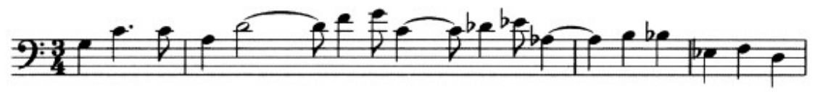
Here is the music for the first time.
Here is the music for the second time.
(b) | Listen to a continuation of the previous excerpt. | 1

Tick one box to identify what you hear.
Here is the music.
Chamber music
Passacaglia
Minimalist
Ritornello

Question 3
This question features music from one period/style.
(a) | Read through the list of features before hearing the music. | 3

Tick three boxes to identify features which are present in the music. The music will be played twice with a pause of 10 seconds between playings and a pause of 20 seconds before the next question starts.
 | Chorale |  | Time changes
 | Countertenor |  | Ballett
 | Obbligato |  | Plainchant
 | Motet |  | Song cycle
 | Madrigal

Here is the music for the first time.
Here is the music for the second time.
(b) | Listen to a different piece and identify the period/style of the music. | 1

Question 4
This question features instrumental music.
(a) | Listen to this excerpt and identify four concepts in the music from those listed below. | 4

You now have 15 seconds to read through the list of features.
Basso continuo | Pavan
Consort | Concertino
Turn | Chorale
Renaissance | Concerto grosso
Hemiola | Mordent
Insert your four answers on the lines below.
1.

2.

3.

4.

The music will be played twice with a pause of 10 seconds between playings and a pause of 40 seconds before part (b).
Here is the music for the first time.
Here is the music for the second time.

Question 4 (continued)
(b) | Listen to a new excerpt. | 1

Tick one box to identify the correct version of the music.
You now have 20 seconds to read through the possible answers.
The excerpt is short and will be played three times.
Here is the music for the first time.
Here is the music for the second time.
Here is the music for the third time.
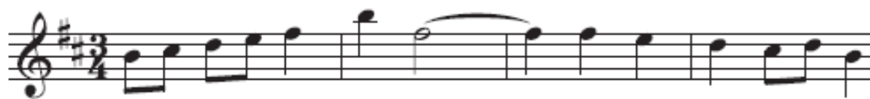

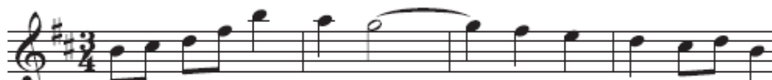

(c) | Listen to a further excerpt from the same work and identify the ornament that is played. | 1

Question 4 (continued)
(d) | Listen to a new excerpt and tick one box to describe what you hear. | 1

You now have 30 seconds to read through the possible answers.
The excerpt will be played twice.
Here is the music for the first time.
Here is the music for the second time.
The ornament is a trill and the music modulates to the relative major.
The ornament is a trill and the music modulates to the relative minor.
The ornament is a mordent and the music modulates to the relative major.
The ornament is a mordent and the music modulates to the relative minor.

Question 5
This question features instrumental music.
Read through the list of features before hearing the music.
Tick four boxes to identify features which are present in the music. The music will be played three times with a pause of 10 seconds between playings and a pause of 20 seconds before the next question starts.
 | Pavan |  | Suspension
 | Galliard |  | Tremolando
 | Chromatic |  | Tierce de Picardie
 | Consort |  | Renaissance
 | Concertino |  | Obbligato

Here is the music for the first time.
Here is the music for the second time.
Here is the music for the third time.
4

Question 6
This question features vocal music.
Listen to the excerpt and follow the guide to the music which is printed on the next page.
Here is the music.
You now have 2 minutes to read through the questions.
(a) | Write the name of the key in the box above bar 1. | 1

(b) | Identify the cadence in bar 3. | 1

(c) | Write the enharmonic equivalent of the boxed note in bar 5. Write your answer on the stave below bar 5. | 1

(d) | Identify the harmonic device used in the final bar. | 1

(e) | Transpose the notes in bar 8 into the bass clef at the same pitch. | 1

You will now hear the music two more times, with 20 seconds between playings and a pause of 1 minute before the next question begins.
You should write all your answers on the guide to the music on the next page.
Here is the music for the second time.
Here is the music for the third time.

Question 6 (continued)
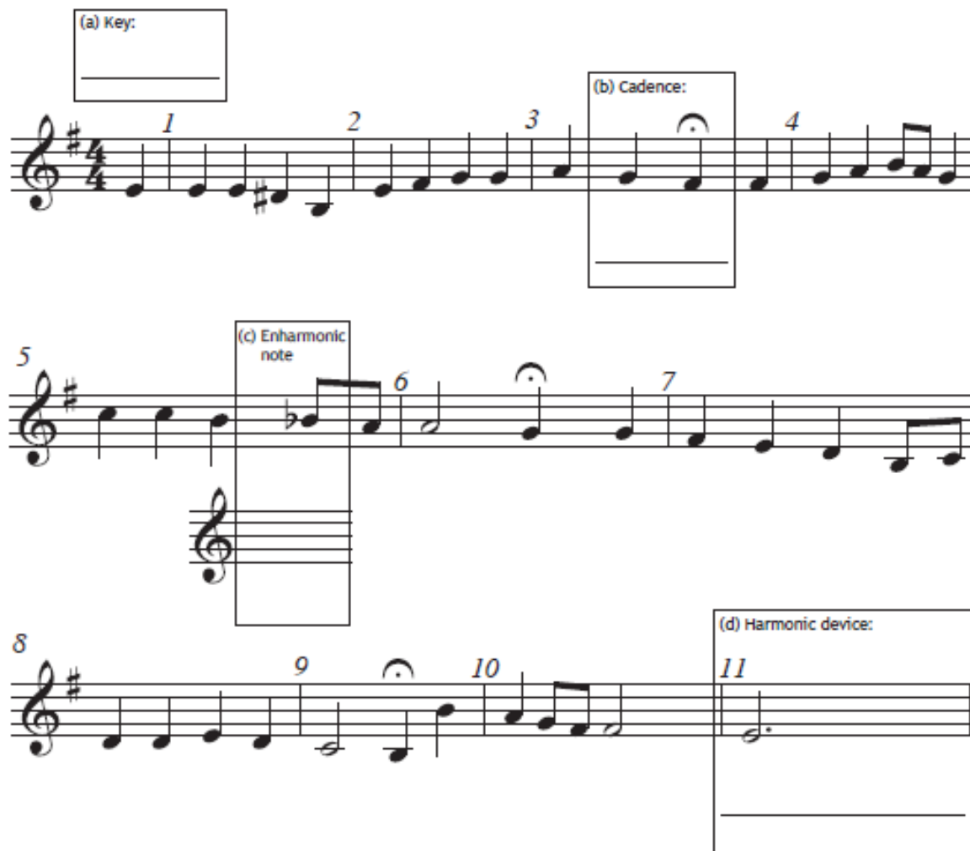

Question 7
In this question you are asked to comment on two excerpts of music.
(a) | Listen to each excerpt. For each excerpt identify at least two prominent concepts in each of the following categories: | 4

- melody and harmony
- timbre and texture
Both excerpts will be played twice, with 15 seconds between playings. After the second playing of Excerpt 2, you will have 4 minutes to complete your final answer.
You may use the rough-work table on the next page. Your final answers should be written on the page that follows it.
Here is Excerpt 1 for the first time.
Here is Excerpt 2 for the first time.
Here is Excerpt 1 for the second time.
Here is Excerpt 2 for the second time.
You now have 4 minutes to complete your final answer.

Question 7 (continued)
Rough work — this page will not be marked.
Categories | Excerpt 1 | Excerpt 2
Melody and harmony
Timbre and texture

Question 7 (continued)
Final answer
(i) | Excerpt 1 | 2

(ii) | Excerpt 2 | 2

Question 7 (continued)
(b) | This question has two parts.

(i) Analyse the two excerpts you have just heard. Your extended answer should refer to six similarities and/or differences across the following categories:
- type of work
- melody and harmony
- timbre
(ii) Conclude by identifying the style/period of each excerpt and justify each answer.
The excerpts will be played again. Use the space below for rough work. Rough work will not be marked.
Rough work

Question 7 (continued)
Final answer
(i) | Analysis — compare the excerpts using six relevant similarities and/or differences. | 4

(ii) | Conclusion — identify and justify the style/period of each excerpt. | 2

[END OF QUESTION PAPER]

